|  |  |  |
| --- | --- | --- |
| **Academic Year:** 2024-25 | **Year:** Second Year | **Term:** II |
| **PRN No.: 1012412079** | **Name: Ratnajeet Patil** | |
| **Subject:** Software Engineering | | |
| **Assignment No.**: 4 |  | |
| **Date: 6/03/2025** |  | |

**Lab Assignment: 04**

* **Title**: Dashboard Screenshot and its link for user stories using Miro/Jira

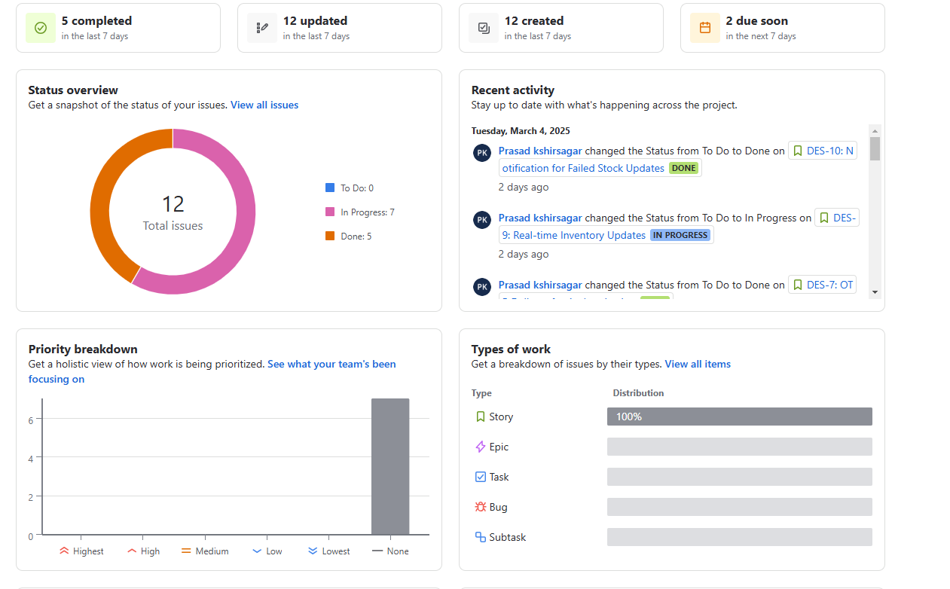

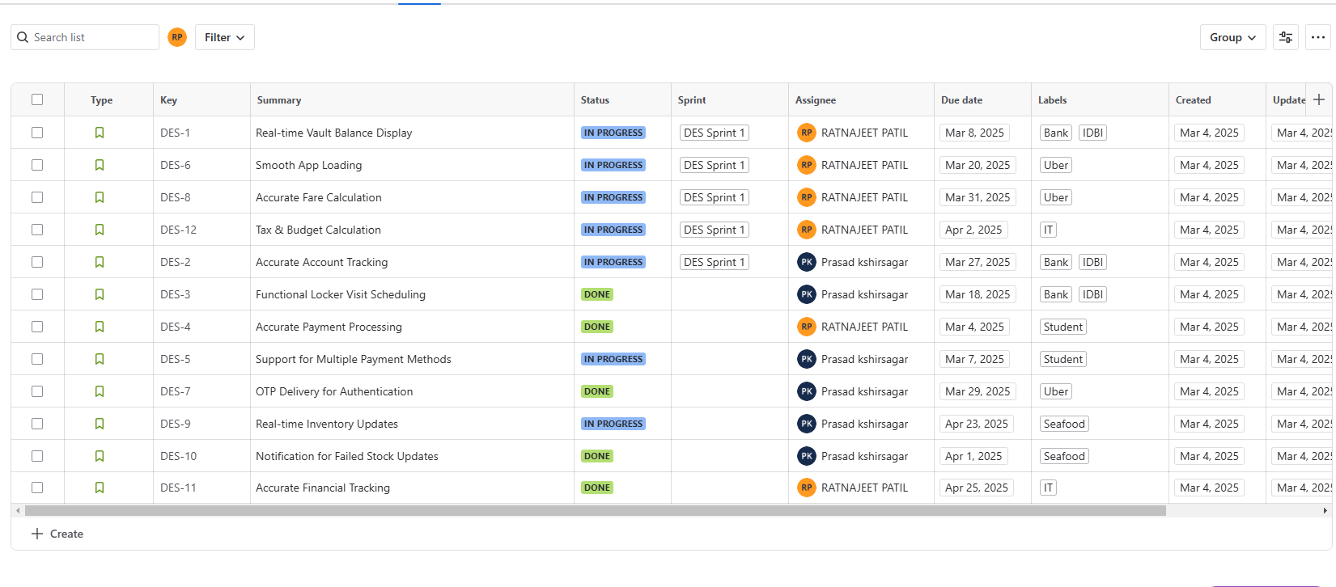

Link

<https://despu-team-hgsnhotc.atlassian.net/jira/software/projects/DES/boards/1?atlOrigin=eyJpIjoiMGJjMjA2ZWIwNGU1NDNiNWJlN2RlZmVhMzYwYTYxYzYiLCJwIjoiaiJ9>